Challenge Grid: Medicine through time
Sources

Source A: From the writings of Henry Buckle, a soldier on the Western Front. He wrote a diary while he was in the trenches and typed it up after the war. Here he describes his situation after being injured in 1915.  leg is not bleeding but it got sort of buried in the trench and twisted up. My sergeant was also injured. Our stretcher people were busy so I told them we could manage to get back by ourselves. It took us all night to get back here to the barn, with lots of sit-downs. The RAMC staff keep coming in but don’t seem able to mend me up. The Medical Officer has been in and says I shall have to go to a Field Hospital for a week. | 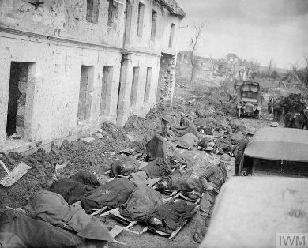  Source B: A photograph showing soldiers on stretchers outside a dressing station on the Western Front during the Battle of Arras, 1917. They are waiting to be transported to a casualty clearing station.
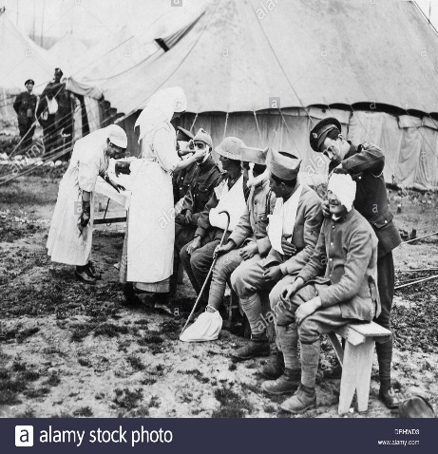  Source C: A photograph showing a British casualty clearing station on the Western Front, c1916. | Source D: From A Nurse at the Front, The First World War Diaries of Sister Edith Appleton by Edith Appleton. Edith’s handwritten diaries were kept by her family until they were published in 2012. She was a trained nurse, working at a military base hospital in northern France. Here Edith is describing the arrival of wounded soldiers at the hospital during the early days of the Battle of the Somme, 1916.  July 4 Wounded! Hundreds upon hundreds, some on stretchers, some being carried, and some walking – and all covered from head to foot in mud. We had to deal with large numbers of horribly bad wounds. Some were crawling with maggots while others were stinking and full of gangrene. One poor lad had been shot in both eyes. Three men had died on the way to the hospital and two died before they could be treated. July 8 The surgeons are amputating limbs and boring holes into skulls at the rate of 30 a day. July 13 I fear one boy may not get better. He has pneumonia caused by a lump of metal in his left lung and I suppose they will not be able to operate on him.
Source E: From Radiography and Radiotheraputic, by Robert Knox, published in 1917. This was a textbook on the use of x-rays written by a British doctor.  The need for portable outfits in connection with the war has led to a great development in the provision of motor wagons containing complete x-ray apparatus with all accessories. The mechanism used for driving the wagon i.e. the motor is coupled with a powerful dynamo which delivers a continuous current. | Source F: RAMC officers posing in front of a mobile bacteriological laboratory in France in 1915  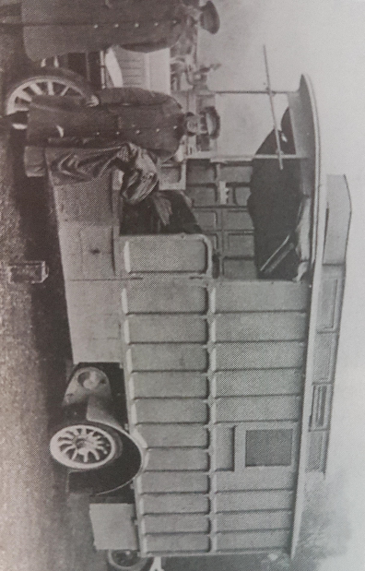
Source G: From the notebook of Lance sergeant Elmer Cotton, who served in the 5th Northumberland Fusiliers in 1915. He is describing the effects of a chorine gas attack.  It produces a flooding of the lungs. It is the equivalent to drowning, only on dry land. The effects are these – a splitting headache and terrific thirst (but to drink is instant death), a knife-edge pain in the lungs and the coughing up of a greenish froth off the stomach and lungs, finally resulting in death. It is a fiendish death to die. | Source H: From a painting by John Singer Sargent was commissioned by the British War Memorials Committee to point this in 1918 and researched the painting by visiting both Arras and Ypres before the end of the war. These soldiers have experienced a mustard gas attack.  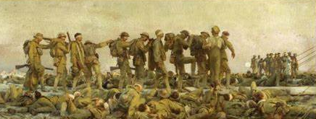

Challenge Grid: Medicine through time Bronze: 52 Silver: 104 Gold: 156
Section A
4 marks 8 marks 12 marks 20 marks

- Study Sources A and B in the Sources Booklet. How useful are Sources A and B for an enquiry into the system for dealing with injured soldiers on the Western Front? Explain your answer, using Sources A and B and your knowledge of the historical context. |  | - Describe two features of blood transfusions on the Western Front during the First World War. | - Study Source A. How could you follow up Source A to find out more about the system for dealing with injured soldiers on the Western Front? In your answer, you must give the question you would ask and the type of source you could use.  Copy out and complete the Follow up table below.
- Study Sources C and D in the Sources Booklet. How useful are Sources C and D for an enquiry into the treatment of battle injuries by medical staff on the Western Front? Explain your answer, using Sources C and D and your knowledge of the historical context. | - Describe two features of the effects of poison gas attacks on soldiers. | - Study Source C. How could you follow up Source C to find out more about the treatment of battle injuries by medical staff on the Western Front? In your answer, you must give the question you would ask and the type of source you could use.  Copy out and complete the Follow up table below | - How could you follow up Source E to find out more about x-rays on the Western Front?  In your answer, you must give the question you would ask and the type of source you could use.
- Describe 2 features of transportation of wounded soldiers from the front line | - How useful are sources G and H for an enquiry into the effects of gas attack during the First World War  Explain your answer, using Sources G and H and your knowledge of the historical context. | - Describe 2 features of the trench environment which unhealthy | - Describe 2 features of the environment at the front line
- Describe 2 features of a dugout | - How could you follow up on source E to find out more about the treatment of the sick  Copy out and complete the Follow up table below | - Study Source H. How could you follow up Source H to find out more about the system for dealing with injured soldiers on the Western Front? In your answer, you must give the question you would ask and the type of source you could use.  Copy out and complete the Follow up table below | - Describe 2 features of the support trench system
Section B
4 marks 8 marks 12 marks 20 marks

16) Explain one way in which care in hospitals in the years c1250–c1500 was different from care in hospitals in the years c1700–c1900. | 17) Explain why there was progress in the prevention of illness in the years c1700–present.  You may use the following in your answer:  • Public Health Act 1875  • Healthy lifestyle campaigns  You must also use information of your own. |  | 18) ‘There was little progress in understanding the cause of disease in the years c1250–c1700.’ How far do you agree? Explain your answer.  You may use the following in your answer:  • The Great Plague in London, 1665  • Thomas Sydenham  You must also use information of your own.
19) ‘The advances in surgery made in the years c1700–c1900 were more significant than advances in surgery made in the period c1900–present.’ How far do you agree? Explain your answer.  You may use the following in your answer:  • Antiseptics  • Transplants  You must also use information of your own. |  |  | 20) Explain why the role of Church in medicine decreased in importance in the years c1250–c1700.  You may use the following in your answer:  • Medical training  • William Harvey  You must also use information of your own.
21) Explain one way in which the methods used by doctors to diagnose illness during the medieval period (c1250–1500) were different from the methods used during the modern period (c1900–present). | 22) ‘John Snow’s work on cholera was a turning point in the prevention of infectious diseases c1700–c1900.’ How far do you agree? Explain your answer.  You may use the following in your answer:  • Jenner’s vaccination  • The Broad Street pump  You must also use information of your own. | 23) Explain one way in which people’s beliefs about the cause of disease were the same in the seventeenth century and fourteenth century | 24) Explain why there was rapid change in the prevention of disease in the period C1700-c1900  How far do you agree? Explain your answer.  You may use the following in your answer  - Inoculation  - Edward Jenner  You must also use information of your own.
25) Government action is the most important reason why there were improvements in care and treatment in hospitals during the nineteenth and twentieth centuries.’ How far do you agree? Explain your answer.  You may use the following in your answer:  • Florence Nightingale  • Government funding  You must also use information of your own. |  | - Explain why there was continuity in the way disease was treated in the period c1500-c1700.  You may use the following information in your answer:  • The Great Plague  • Attitudes in society  You must also use information of your own. | - Explain one way in which people’s reactions to the plague in Britain were similar in the fourteenth and seventeenth Century

