Challenge Grid: Weimar and Nazi Germany 1918-39
4 marks 8 marks 12 marks 20 marks Bronze: 50 Marks Silver: 100 Gold 150

- Give two things you can infer from Source A about the Spartacists. | - Explain why there was increased support for the Nazis in the years 1929-32.  You may use the following in your answer: (+ you must use your own points)  - Unemployment  - Goebbels |  | - Study Interpretations 1 and 2. They give different views about the extent of German recovery in the years 1924-29. What is the main difference between these views? Explain your answer, using details from both interpretations.
- How far do you agree with Interpretation 3 about the role of the SS in the Nazi police state? Explain your answer using both interpretations (Interpretations 3 and 4) and your own knowledge of the historical context. |  | - Give two things you can infer from source E about German Recovery | - Explain why there were challenges to the Weimar Republic in the years 1919-23.  You may use the following in your answer: (+ you must use your own points)  - The Treaty of Versailles  - The Kapp Putsch
- How useful are sources G and H for an enquiry into attitudes in Germany towards the Treaty of Versailles? Explain your answer using Sources G and H and your own knowledge of the historical context. |  | - Give two things you can infer from Source B about Hitler’s early career.
- Give two things you can infer from Source C about Hitler’s attitude towards the Jews. | - How far do you agree with Interpretation 5 about the reasons for increased support for the Nazi Party in the years 1929-32?  Explain your answer, using both interpretations (Interpretations 5 and 6) and your knowledge of the historical context. | - How useful are Sources I and J for an enquiry into the role of Hitler in increasing support for the Nazis in the years 1929-32? Explain your answer using Sources I and J and your knowledge of the historical context. | 11) Explain why sport changed under the Nazis in the years 1933-39. You may use the following in your answer: (+ you must use your own points)  Healthy Nation – Racial Beliefs
- How useful are Sources K and L for an enquiry into the concerns Hitler had about the SA? Explain your answer, using sources K and L and your knowledge of the historical context. | - Give two things you can infer from Source D about the Weimar Constitution. | - How useful are Sources M and N for an enquiry into the Reich Labour Service? Explain your answer using Sources M and N and your knowledge of the historical context. | - Give two things you can infer from Source F about Hitler’s Views on Politics

Sources & Interpretations
Interpretations

Interpretation 1: From Weimar and Nazi Germany, F. Reynoldson, published in 1996  ‘From 1924 to 1929 the Weimar Republic was much stronger than it had been just after the war. Led by Stresemann in the Reichstag, the different parties managed to work together. The extreme parties such as the Nazis gained fewer seats in the elections. The German people were better off and more contented. The Weimar Republic looked safe.’ | Interpretation 2: From Weimar and Nazi Germany, E. Wimlott, published in 1997  ‘German prosperity was built on quicksand foundations. The Weimar economy was dependent upon high-interest American loans, which usually had to be repaid or renewed within three months. In times of depression, US moneylenders could demand rapid repayment. Moreover, unemployment never fell below 1.3 million. Although big business grew in the 1920s, small firms struggled and many went bankrupt.’
Interpretation 3: An extract from Years of Weimar and the Third Reich by D. Evans and J. Jenkins, published in 1999  ‘The SS members were totally dedicated to what they regarded as the supreme virtues of Nazi ideology – loyalty and honour. They saw themselves as the protectors of the Aryan way of life and the defenders of the people against the agitators, the criminal classes and those they saw as being responsible for the Jewish-Communist threat.’ | Interpretations 4: An extract from Documents on Nazism 1919-45 by J. Noakes and G. Pridham, written in 1974  ‘Hitler needed an organisation which would not feel restrained by the law. It would act with utter ruthlessness and would need to be dedicated to expressing his will and the ideas of the Nazi movement. He found what he needed in the SS.’
Interpretation 5: From a history textbook, GCSE Modern World History, B. Walsh, published in 1996  ‘The Nazis won increased support after 1929 due to Hitler. He was their greatest campaigning asset. He was a powerful speaker and was years ahead of his time as a communicator. He travelled by plane on a hectic tour of rallies all over Germany. He appeared as a dynamic man of the moment, the leader of a modern party with modern ideas. At the same time, he was able to appear to be the man of the people, someone who knew and understood the people and their problems. Nazi support rocketed.’ | Interpretation 6: From a history textbook, Modern World History, T.Hewitt, J. McCabe and A. Mendum, published in 1999  ‘The Depression was the main reason for increased support for the Nazis. The government was taken by surprise at the speed and extent of the Depression. It also had very few answers as to how to deal with it. The Depression brought out all the weaknesses of the Weimar Republic, which seemed to be incapable of doing anything to end it. It is not surprising that the German people began to listen to parties promising to do something. In particular, they began to look to and support the Nazis.

Sources (4 Markers):

Source A: From an article in a government newspaper, 1919  ‘The despicable actions of Liebknecht and Rosa Luxemburg soil the revolution and endanger all its achievements. The masses must not sit quiet for one minute longer while these brutal beasts and their followers paralyse the activities of the republican government and incite the people more and more to civil war.’ | Source B: From Mein Kampf, written by Hitler in 1924. Here he is describing his time in Vienna  ‘My life was a continuous struggle with hunger … I had but one pleasure – my books. At that time I read enormously and thoroughly … In this way I forged in a years’ time the foundation of a knowledge from which I still draw nourishment today … In this period there took shape within me a world picture and a philosophy which became the granite foundation of all my acts. In addition to what I then created, I have had to learn little and I have had to alter nothing.’
Source C: From a speech given by Hitler in 1922  ‘There can be no compromise. There are only two possibilities: either victory of the Aryan master race, or the wiping out of the Aryan and the victory of the Jew.’ | Source D: From a speech to the new Constituent Assembly by Hugo Preuss, head of the Commission that drew up the Weimar Constitution in 1919. He was talking about the new constitution.  ‘I have often listened to the debates with real concern, glancing timidly to the gentlemen of the Right, fearful lest they say to me: ‘Do you hope to give a parliamentary system to a nation like this, one that resists it with every sinew in its body?’ One finds suspicion everywhere; Germans cannot shake off their old political timidity and their deference to the authoritarian state.’
Source E: From a German journalist, written in 1930  In comparison with what we expected after Versailles, Germany has raised herself up to shoulder the terrific possible. So that today after 10 years, we may say with certainty ‘even so, it might have been worse’. The stage of convalescence from Versailles is a very long road to go and have travelled in surprisingly quickly | Source F: Comments made by Hitler as a prisoner in Landsberg. He was speaking to a fellow Nazi inmate  When I resume active work, it will be necessary to follow a new policy. Instead of working to achieve power by armed conspiracy, we shall hold our noses and enter parliament against the Catholic and Communist members. If out-voting them takes longer than out-shooting them, at least the results will be guaranteed by their own constitution. Sooner or later, we shall have a majority in parliament.

Source G: From a German newspaper, Deutsche Zeitung, 28 June 1919  ‘Vengeance! German nation! Today in the Hall of Mirrors [Versailles] the disgraceful treaty is being signed. Do not forget it. The German people will, with unceasing work, press forward to reconquer the place among nations to which it is entitled. Then will come vengeance for the shame of 1919.’ | 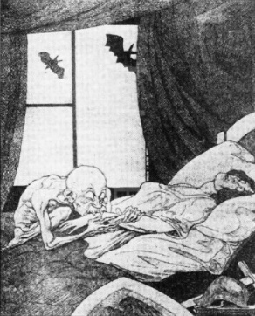  Source H: A cartoon entitled ‘Clemenceau the Vampire’. From the German right-wing satirical magazine Kladderadatsch, July 1919. Clemenceau was the leader of France. The cartoon is commenting about the treaty of Versailles.
Source I: Adapted from the diary of Luise Solmitz, 23 March 1932. A schoolteacher, Solmitz was writing about attending a meeting in Hamburg at which Hitler spoke  ‘There stood Hitler in a simple black coat, looking over the crowd of 120,000 people of all classes and ages … a forest of swastika flags unfurled the joy of this moment showed itself in a roaring salute … The crows looked up to Hitler with touching faith, as their helper, their saviour, their deliverer from unbearable distress … He is the rescuer of the scholar, the farmer, the worker and the unemployed.’ | 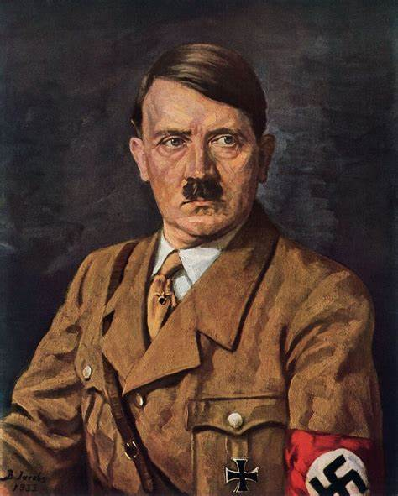  Source J: A portrait of Hitler painted in 1933 by B. Von Jacobs
Source K: From a report by Wilhelm Frick, Minister of the Interior, 6 October 1933  ‘Despite repeated announcements by the Reich Chancellor [Hitler], and despite numerous circulars, new infringements by subordinate leaders and by members of the SA have been reported again and again during the past weeks. Above all, SA leaders and SA men have carried out police actions for which they had no authority whatever… and which cannot be reconciled with the existing laws and regulations. These infringements must now stop.’ | Source L: From comments made by Ernst Rohm to Kur Ludecke in January 1934. Ludecke was a fundraiser for the Nazi party and was a close friend of Rohm.  ‘Hitler can’t walk over me as he might have done a year ago; I’ve seen to that. Don’t forget that I have three million men, with every key position in the hands of my own people, Hitler knows that I have friends in the Reichswer [Germany’s armed forces], you know! If Hitler is reasonable I shall settle the matter quietly; if he isn’t I must be prepared to use force – not for my sake but for the sake of our revolution.’
Source M: An Austrian visitor describes a Labour Service camp in 1938  ‘The camps are organised on thoroughly military lines. The youths wear uniforms like soldiers. The only difference is that they carry spades instead of rifles and work in the fields.’ | 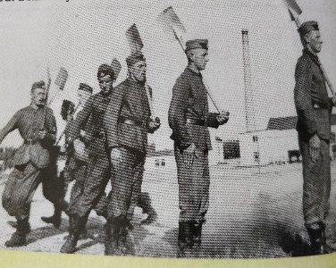  Source N: Young men in the Labour Service carrying out a military drill 1933
Sources (8 Markers)

